Practical 2
Question:
Write a C program to create a child process using fork() and display the PID and PPID of both the parent and the child process. The parent process must wait for the child to terminate using wait() before it exits.
Code:
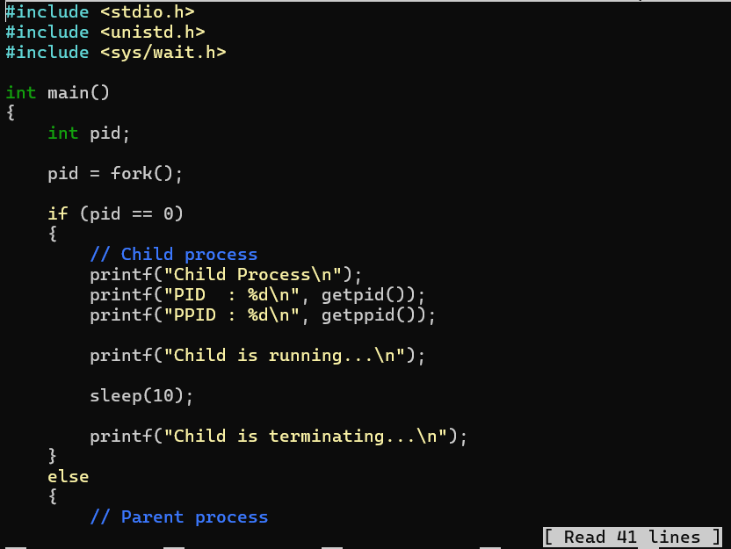
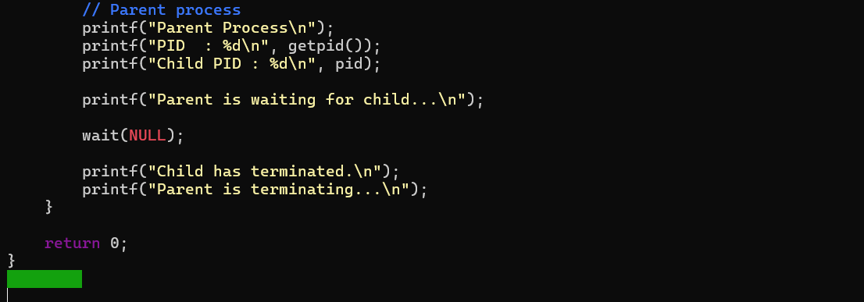
Output:
